f

Self-serve BI & Data Analytic Architecture within MS Fabric

Self-serve Data Domain Onboarding Process

Date of Issue: 10/10/2025
Version #: 1.0
Author: Pavel Aleman

Table of Contents
Table of Contents 2
Self-serve BI & Data Analytic Architecture within MS Fabric Change Control & Distribution Log 3
Self-serve BI & Data Analytic Architecture within MS Fabric Roles and Responsibilities 3
Executive Summary 5
Extended Executive Summary 5
Mission Statement 6
Vision Statement 6
Introduction. 7
Self-Serve Data Domains: A Strategic Path to AI Readiness. 7
Governance Guiding Principles 8
Domain Onboarding Paths 8
1. Business Ready to Take Domain Admin Role 8
2. Business Not Ready to Take Domain Admin Role 9
Domain Onboarding Process Steps 9
1. Request & Intake 9
2. Official Readiness Assessment 9
3. Domain Onboarding Path 9
4. Purview Integration 10
Roles & Responsibilities 10
Tenant/Enablement Team 10
Domain Team 10
Swimlane Diagram - Domain Onboarding Paths 11
Appendix : Fabric Domain Components details. 12
Azure Cloud Security services 12
BoC Fabric Enablement services 12
BoC Purview Platform services (in-progress) 12

Self-serve BI & Data Analytic Architecture within MS Fabric Change Control & Distribution Log
Version, Date & Author | Purpose | Description of Change and Distribution
Version: 0.1  Date: September 9, 2025  Author(s): Pavel Aleman | Input | Initial version of document leveraging Exchange SAD
Version: 1.0  Date: October 10, 2025  Author(s): Pavel Aleman | Input | Request to input members to provide feedback on sections important to them.

Self-serve BI & Data Analytic Architecture within MS Fabric Roles and Responsibilities
Role | Assign To
Recommend  (Individual or group accountable for producing the deliverable) | Pavel Aleman, Enterprise Architect
Approve  (individual or group accountable for approving this document | DDS Architecture Review Board (ARB)  Hajer Zaiem, Director  Louis Bergeron, Director
Concur  (individuals or groups asked to support and endorse the contents of the deliverable) | Richard Dea AD, Business Intelligence and Insights - DDS  Dylan Spevack-Willcock, Manager, Information Governance and Standards - DDS
Input  (individuals or groups asked to provide views, requirements and information to the deliverable and may be actively involved in producing the deliverable) | Paul Guibord, Assistant Director, SAP and AI tooling  Charlie Alswiti, Solution Architect  Ramesh Paskarathas, Principal Analyst  Ivan Araujo, Business Analyst  Agnes Wong, Metadata and Standards Analyst
Notify  (individuals or groups notified of the deliverable) | Leadership Team  Project Team  Self-serve Data Domains of Triton, DAS, IMPACT  All of the above (R, A, C, I)

BoC Data Domain Onboarding Process.
Self-serve BI & Data Analytic Architecture within MS Fabric

Executive Summary
The Domain Onboarding Process defines the formal pathway for business units at the Bank of Canada to be part of the Managed Self-Service Data Analytics ecosystem, ensuring each Self-service Data Domain is securely provisioned, operationally ready, and aligned with enterprise governance.
The Fabric Enablement Team evaluates business readiness for owning and managing a self-serve Data Domain, provisions technical environments in Microsoft Fabric and Purview, and guides governance practices. Depending on maturity, domains are onboarded either fully autonomous or in assisted mode, with gradual capability building.
This structured approach empowers domains to manage data products independently while maintaining compliance, security, and alignment with the Bank’s Data Mesh strategy

Extended Executive Summary
The Domain Onboarding Process defines the formal pathway for a business unit at the Bank of Canada to become an active participant in the Managed Self-Service Data Analytics ecosystem. This process ensures that each Data Domain is properly equipped, governed, and aligned with the Microsoft Fabric, Microsoft Purview, and Azure platforms under the Data Mesh architecture.
Through structured onboarding, the Fabric Enablement Team evaluates domain readiness, provisions technical environments, and ensures compliance with governance and security standards. Depending on the business unit’s maturity, domains are onboarded through one of two paths:
- Fully Ready: The business assumes full domain administration.
- Assisted Mode: The Fabric Enablement Team temporarily performs administrative functions while building domain capabilities.
This process ensures every new domain achieves secure autonomy, operational readiness, and alignment with enterprise governance, enabling faster delivery of trusted data products and advancing the Bank’s AI and analytics strategy.

Mission Statement
To ensure every new Self-serve Data domain is securely onboarded, operationally ready, and empowered to manage data products autonomously within Microsoft Fabric, while maintaining enterprise governance, compliance, and alignment with the Bank’s Data Mesh strategy.

Vision Statement
To create a scalable and well-governed self-service data ecosystem where business domains operate independently yet cohesively — accelerating analytics, innovation, and AI readiness across the Bank of Canada.

Introduction.
The Domain Onboarding Process serves as the entry point for business units into the Bank of Canada’s Data Mesh operating model, enabling them to become a Self-Service Data Domains within the Microsoft Fabric platform.
A Self-Serve Data Domain is a domain-specific operating model supported by the BoC Fabric Enablement team, designed to enable the Managed Data Analytic Self-service. It provides security services, automation, and governance to boost productivity and self-service capabilities.
A self-serve Data Domain is composed by:
- Azure Foundation Services (DevOps CI/CD, security groups, Key Vaults, SPNs).
- BoC Fabric Enablement Services (self-serve landing zone, workspace provisioning, accelerators, and monitoring tools).
- Fabric Self-Serve Domain Components (landing zone workspace for ingestion and domain workspaces for data pipelines and products).
- Microsoft Purview Integration (data governance, product cataloging, and lineage for enterprise transparency).
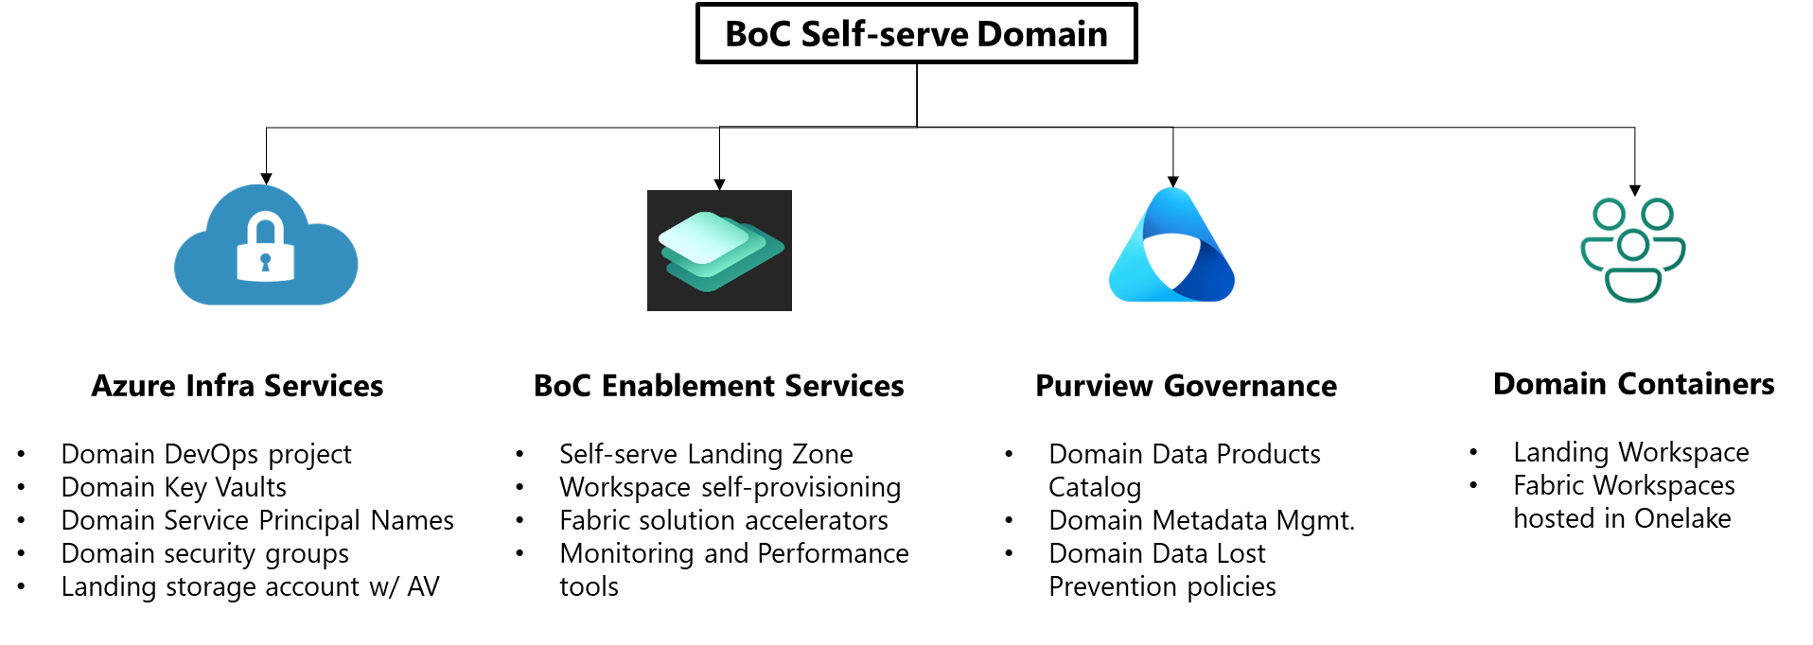
Depending on readiness, business units can either take full ownership of the Self-serve Domain, immediately or enter an Assisted Mode, where the Fabric Enablement Team provides temporary administrative support until full capability transfer is achieved.

Self-Serve Data Domains: A Strategic Path to AI Readiness.
Since early 2022, BoC has strategically developed a self-serve data ecosystem—progressing from foundational BI tools to advanced analytics and AI/ML readiness. This evolution reflects a clear shift toward decentralized data access, empowered domain teams, and scalable enterprise AI enablement.
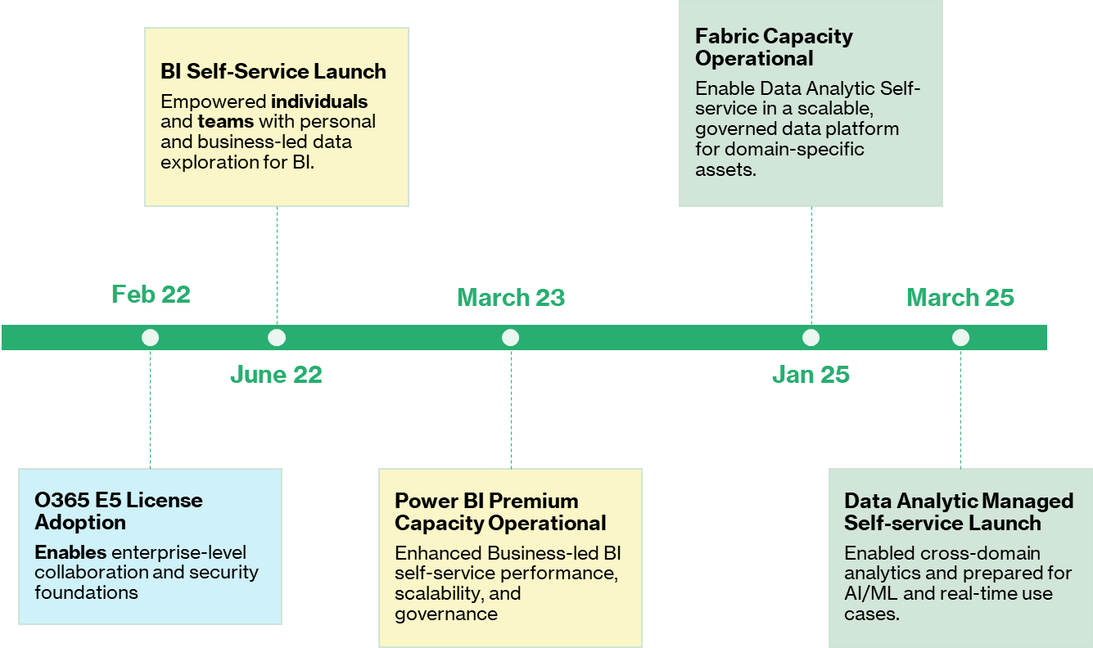

Governance Guiding Principles
- Autonomous Governance: Business Self-serve Data Domain administrators manage workspaces, developed domain data products and governance policies independently, ensuring full administrative control. Domains comply with tenant-level governance standards and policies.
- Decentralized Accountability: Domains are accountable for their own data and analytics products.
- Enterprise Alignment: Tenant-level governance ensures global policies, automation, and security.
- Technology-Agnostic – A Self-serve Data Domain is not bound to a single technology such as MS Fabric. Instead, it is domain-specific operating model supported by the BoC Fabric Enablement team that provide a group of services from different Azure technologies/platforms based on their ability to deliver the required capabilities for data analytics, governance, and security.

Domain Onboarding Paths
Two onboarding paths are available depending of the readiness level of the business client to take the role of Self-serve Data Domain administrator.

1. Business Ready to Take Domain Admin Role
In this scenario, the business unit is fully prepared to assume the responsibilities of a domain administrator. The onboarding process includes:
- Assignment of domain ownership and governance responsibilities.
- Provisioning of workspaces and capacities aligned with the domain.
- Configuration of Purview policies and cataloging for the domain.
- Enablement of self-service capabilities and DevOps practices.
- Training and process documentation provided by the Fabric Enablement Team.

2. Business Not Ready to Take Domain Admin Role
In this scenario, the business unit is not yet ready to perform domain administrator actions. The Fabric Enablement Team temporarily performs these actions with approval from the business's training administrators. The onboarding process includes:
- Temporary Administrative Support​: Enablement Team provides admin support and executes administrative tasks on behalf of the domain while the business domain lacks full administrative readiness.​
- Approval and Accountability​: Business remains accountable for governance decisions and domain strategy.
- Governance training and Knowledge Transfer​: Gradual governance transition plan to transfer admin responsibilities to the business.

Domain Onboarding Process Steps

1. Request & Intake
Onboarding starts when a business unit submits a domain onboarding request using the DDS Help Desk service form
The Business submits all required information including business unit justification, proposed domain name, data owners of the operational and analytic data sources in scope, current and proposed analytic data stewards, expected final data products and consumers, and readiness self-assessment for domain administration assessment.

2. Official Readiness Assessment
The domain’s readiness is assessed to ensure it can handle administrative and governance responsibilities effectively. The Fabric Enablement Team evaluates governance and stewardship maturity, technical readiness, alignment to Data Mesh principles, and training completion.
Decision: Fully Ready or Not Ready (Training Required).

3. Domain Onboarding Path
This initial step sets expectations and prepares the domain for its critical governance role within the company, two onboarding paths exists depending of the readiness level the business client for administering a Data Domain.
Option A – Fully Ready: The business unit will take on the full Domain Admin role, while the Enablement Team provides advisory support and organizes the New Domain onboarding handover. During this handover, the required roles, tools, accounts, process and workspaces are created and formally transferred to the new business domain administrators
Option B – Assisted Mode: New Domain is created with its roles, tools, accounts, and workspaces, but the Domain Admin role is temporarily granted to the Enablement Team. The future business domain administrators participate in training during this period, while the business unit remains accountable for all governance decisions and must approve the actions executed by the Enablement Team.

4. Purview Integration
The Enablement Team will register the New domain in Purview Data Map, configure metadata, ownership, classification, assign roles, and link Fabric workspaces.
Option A – Fully Ready: The business unit will take on the full responsibility of defining and managing Data Products in Purview.
Option B – Assisted Mode: Data Product Admin role is temporarily granted to the Enablement Team

Roles & Responsibilities

Tenant/Enablement Team
Scope: Own and support Domain readiness decisions, configure new Domains, and communicate governance and support processes to new Domain owners, as well as provide training for business units that are not yet fully ready.
Responsibilities:
- Own and support Domain readiness decisions.
- Configure new Domains in MS Fabric and Purview.
- Communicate governance and support processes to new Domain owners.
- Provide training and guidance on domain administration for business units that are not yet fully ready

Domain Team
Scope: Request Domain onboarding by providing all necessary information accurately, submit an objective and realistic self-assessment of skills for Domain administration, and manage and support data, clients, and data products within the Domain’s scope.
Responsibilities:
- Submit Domain onboarding requests with complete and accurate information.
- Provide a realistic self-assessment of skills required for Domain administration.
- Manage and support data within the Domain, ensuring quality and compliance.
- Support clients and stakeholders by facilitating access and usage of Domain data.
- Oversee data products under the Domain, ensuring proper registration, maintenance, and lifecycle management.

Swimlane Diagram - Domain Onboarding Paths
 | Fabric Enablement Team | Domain Team
1. Request & Intake |  | Submit Domain Request Form with required information
2. Official Readiness Assessment | Evaluate readiness, governance maturity, training
3. Decision Point | Decide: Fully Ready or Not Ready
4. Domain Onboarding Path – Option A: Fully Ready | Advisory support, organize handover | Take full Domain Admin role
4. Domain Onboarding Path – Option B: Assisted Mode | Temporarily act as Domain Admin, execute actions with approval | Remain accountable, approve actions, participate in training
5. Purview Integration  – Option A | Advisory support, organize handover | Define and manage Data Products in Purview
5. Purview Integration  – Option B | Temporarily manage Data Products in Purview | Approve actions, transition to ownership

Appendix : Fabric Domain Components details.

Azure Cloud Security services
- Key Vaults:
  - Domains administrator’s Key Vault
  - Domain Developers’ Key Vault
- Identities and security Groups
  - Domain Admins AD group
  - Domain developers AD group
  - Admin Service Principal Name SPN
  - Domain Landing Zone SPN
- Azure DevOps: Domain DevOps project

BoC Fabric Enablement services
- Self-serve Fabric Landing zone service:
  - Automatic Antivirus Defender for Storage cleaning process
  - Domain Landing Storage Container (ADLS gen2)
  - Domain Landing workspace with Landing notebook template
  - Managed Private Endpoint between Domain Landing storage container and Domain landing workspace
- Data templates and Data usage Monitoring & Performance tools:
  - Content Sharing Report
  - Feature Usage and Adoption Report
  - Purview governance hub
  - Fabric Solution Templates Workspace
- Automatic Usage monitoring and notification service
- Self-serve Workspace Provisioning service

BoC Purview Platform services (in-progress)
- Self-serve Data Product mgmt. service
- Self-serve Domain Data Protection Polices DLP. service

